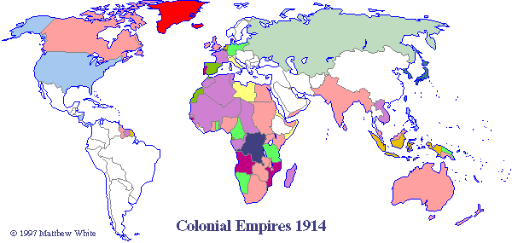

Imperialism and the Balance of Power

